Celeste Padilla
Third Grade
Subject: Math-Geometry
Date: 2/26/14
Lesson Plan 1: What Makes a Shape
Whole class

Standards: CCSS.MATH.CONTENT.3.G.A.1
Understand that shapes in different categories (e.g., rhombuses, rectangles, and others) may share attributes (e.g., having four sides), and that the shared attributes can define a larger category (e.g., quadrilaterals). Recognize rhombuses, rectangles, and squares as examples of quadrilaterals, and draw examples of quadrilaterals that do not belong to any of these subcategories.

Content Objective: Students can identify different attributes (lines, angles, sides, length) on different quadrilaterals.

Language Objective: Students will be able to orally compare and contrast two different quadrilaterals using Topic 5 vocabulary (see below)

I noticed quadrilateral ___ has __________________________ .
(#)
I noticed quadrilateral ___ and quadrilateral __ both have ___________________________.
(#) (#)

Vocabulary
- Parallel lines
- Perpendicular lines
- Right angle
- Obtuse angle
- Acute angle
- Side
- Length

Assessment:
Formative: I will circulate around the room during exploration and listen in on partner conversations to assess individual and general class understanding. I will take notes of my observations on an index card. I will ask students the following questions as I circulate:
- How can you use the attributes to help you compare and contrast the shapes?
- Do you notice any similarities or differences between your shapes?
- Why do you think that?
- Is it possible for shapes to fit into more than one category?
- Are you noticing any patterns?

Summative: Students will complete their exploration sheets. I will collect and read these sheets to assess individual and class understanding. I will use calling cards to complete our class exploration chart.

Materials needed:
- Flipchart Topic 5
- Quadrilateral exploration sheet
- Signs for the centers
- Different quadrilateral cut outs (# labeled)
- Pencils
- Ruler (print out)
- Right angle tool (index card)

Differentiation:
AM and ReM will be sat in the front to limit distractions.

Students will be strategically paired such as IL/NB, AB/AM, ReM/LG, YC/JP, and SG/DA.

IL and NB will be paired up because I supports N’s needs and give I sense of responsibility

KR needs plenty space to write on his paper and a weighted pencil.

Activity itself lends itself to differentiation because there are multiple entry and exit points. There is language support with sentence stems and content support with guiding questions but students are free to explore other attributes and discuss it a more complex manner.

Instructional Sequence:
Introduction
- Tap Prior Knowledge: Students will meet at the Promethean quickly and quietly and bring a pencil. We will read today’s objective. I will tap prior knowledge from the previous lesson (The Greedy Triangle). “Yesterday we looked at the different attributes of different polygons, the attributes we looked at were angles, sides, and vertices. Today we are going to explore and learn more about quadrilaterals.” (highlight quadrilaterals on the sheet projected) “We are going to be going to different exploration centers the same way we explored solid figures, except today we will be exploring different quadrilaterals.”
- Introduce Assignment/Model: I will explain the objective and model the assignment. “Today we are going to be comparing and contrasting quadrilaterals by seeing what attributes they have in common and how they differ. Together let’s think of some of the ways we can compare and contrast them (call on student volunteers and record answers on the board, make sure to mention that we can examine angles, side lengths, and types of lines).”
- I will now model how to compare and contrast attributes with a partner (Mr. C will be my partner). I will also introduce and pass out the worksheet at this time at this time I will have them write their names on the paper. “Right now we are going to work together to compare and contrast our first set of quadrilaterals. Notice on the paper and on the board we will be using a Venn diagram. Before we write anything down, we must first talk with our partner about what we notice and agree before writing. So Mr. C is my partner, what do you notice about the quadrilaterals, remember we can use the list we created to help us look at the different attributes. I noticed that quadrilateral 1 has one set of parallel lines. Let me check (model how to check again for parallel lines), I agree let’s write that down for quad 1, now let’s look at quad 2” I will continue this process of a think aloud about how to talk with a partner about an attribute and whether only one quadrilateral has it or both, once we agree the whole class will record the answer of the sheet. Sentence frames will also be modeled during this process. This process will be repeated once more as a model then twice with their partner on the carpet. I will listen in on conversations then use calling cards to record observation on the Promethean.
- Show them the centers and repeat instructions. “Follow me with your eyes, we will be having different centers at each table, notice that each table has a letter on it, if you are at A your next center is B, if you were at B your next center is C (repeat this and walk to each center up to the last center F). Can someone repeat the directions please? (volunteer then calling cards).” “Remember you will be working with a partner, talk and agree before writing, look at the list we made to help you observe different attributes, and remember to use the sentence frames, can someone please help repeat the directions back (volunteer then calling cards) okay great, I will use the timer and you will have 7 minutes at each center (monitor time whether students will need more or less than the 7), have fun exploring everyone!” (Students will be dismissed to tables, DG + VS and JR + NC will create their own table 6)
Body
- Exploration: I will circulate around the room during exploration and listen in on partner conversations to assess individual and general class understanding. I will take notes of my observations on an index card. I will ask students the following questions as I circulate:
- How can you use the attributes to help you compare and contrast the shapes?
- Do you notice any similarities or differences between your shapes?
- Why do you think that?
- Is it possible for shapes to fit into more than one category?
- Are you noticing any patterns?
Closure
- Wrap it up: Students will meet back at the Promethean board sitting next to their partners and they will bring their exploration sheet. I will praise the students for what I saw they were doing well during the exploration. “Great job exploring today my mathematicians, you worked well with your partners and closely observed the different attributes of the quadrilaterals!!”We will record our observations in a class chart, I will use calling cards( 4 for each set) for students to share out. In addition, I will ask students to give a thumbs up or down if they got the same thing. We will revisit our attributes list and discuss the importance of looking at attributes in comparing and contrasting shapes, I will also highlight the attributes of lines, angles, and sides. I will explain that tomorrow we will be exploring specific types of quadrilaterals and that these attributes are going to be really important to look at. I will ask students to double check that they have their name on their exploration sheets and to please make a pile on their desks, I will come and collect the papers.

Instructional Materials: Flipchart
Lesson Plan 1:1
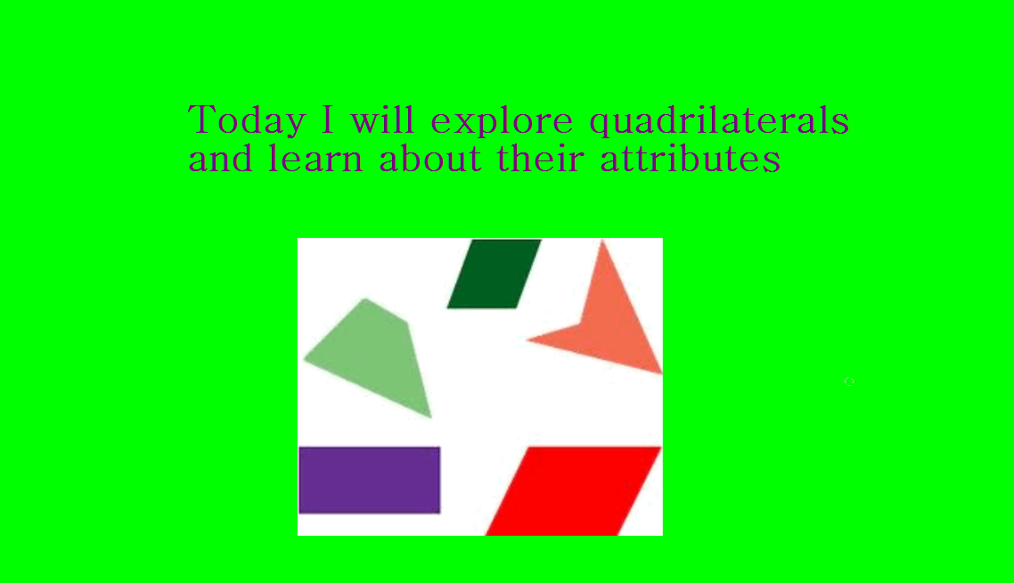
Lesson Plan 1:2
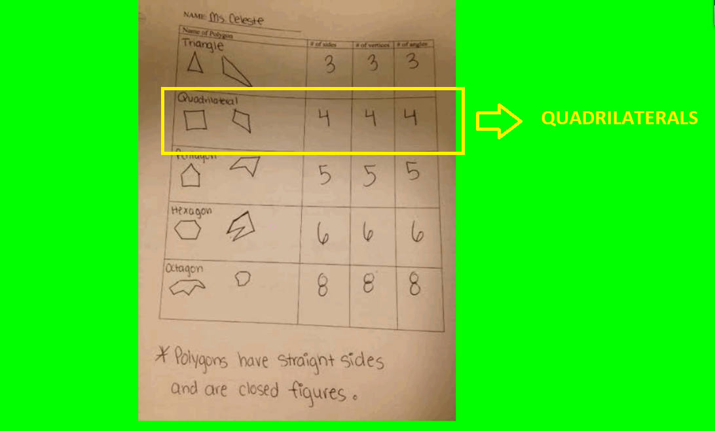

Lesson Plan 1:3

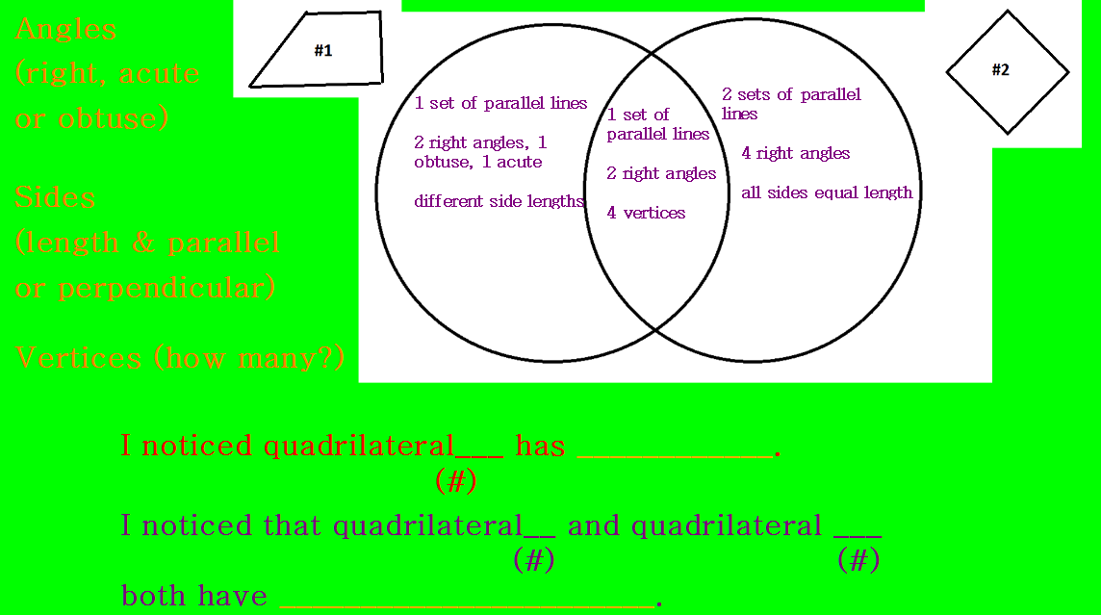

Lesson Plan 1:4
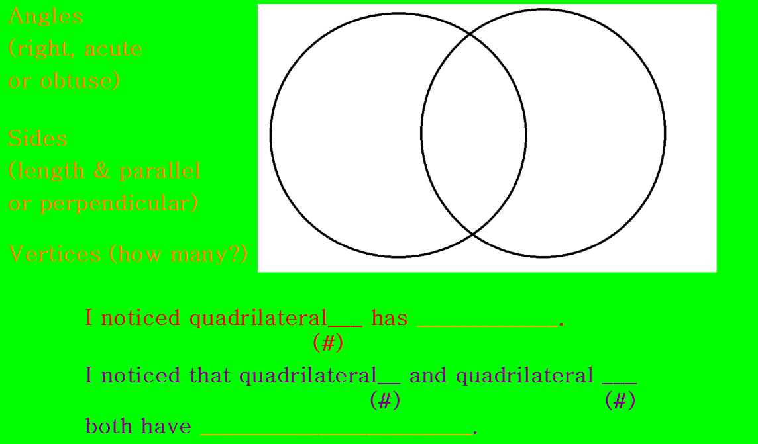

Instructional Materials: Center signs + quadrilateral cut outs and ruler
Lesson Plan 1:5
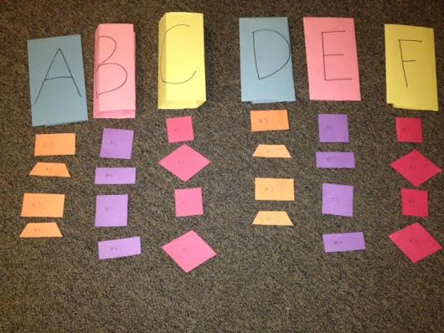
Lesson Plan 1:6
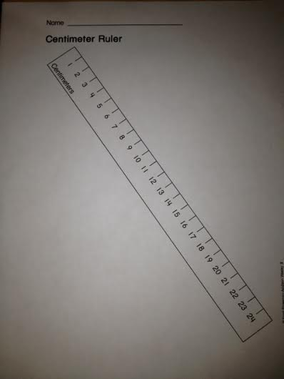
Instructional Materials: Handout (size adjusted to fit in document)
Lesson Plan 1:7
Name: ________________________________

Quadrilateral Exploration
Example:

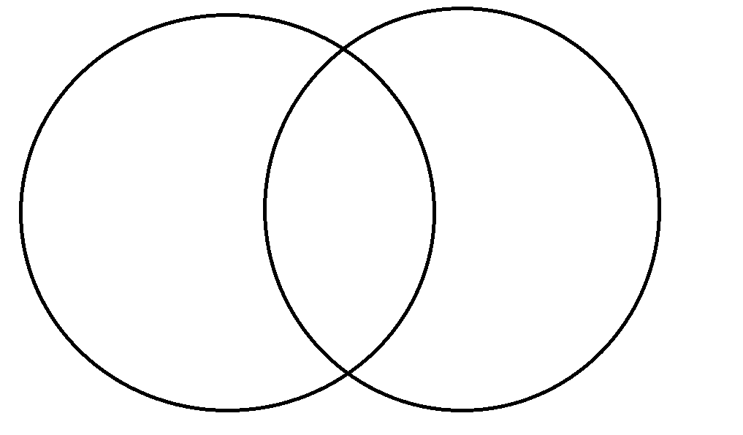
Center _____
Center ______
Center _______

Celeste Padilla
Third Grade
Subject: Math-Geometry
Date: 2/27
Lesson Plan 2: Quadrilateral names
Whole class

Standards: CCSS.MATH.CONTENT.3.G.A.1
Understand that shapes in different categories (e.g., rhombuses, rectangles, and others) may share attributes (e.g., having four sides), and that the shared attributes can define a larger category (e.g., quadrilaterals). Recognize rhombuses, rectangles, and squares as examples of quadrilaterals, and draw examples of quadrilaterals that do not belong to any of these subcategories.

Content Objective: Students will be able to identify common attributes shared by the same type of quadrilateral. Student will be able to identify the different types of quadrilaterals.

Language Objective: Students can make a generalization statement about the attributes a specific type of quadrilateral possesses.

I noticed all ______ all have ________________.

Vocabulary
- Quadrilateral
- Rhombus
- Square
- Rectangle
- Parallelogram
- Trapezoid
- Parallel lines
- Right angle
- Side
- Length (different or equal)

Assessment:
Formative:
Students will TPS during the introduction to the lesson and modeling. I will listen in on these conversations and then use the calling cards.

During centers exploration, I will circulate around the room and listen in on partner conversations. I will take notes of individual and class understanding on my note card. I will ask students the following questions:
- What do you notice?
- Why did you say that, can you explain your thinking?
- What do they ALL have in common?
- Have you noticed any patterns?

Summative: Students will complete their exploration sheets. I will collect and read these sheets to assess individual and class understanding. I will use calling cards to complete our class exploration chart.

Materials needed:
- Topic 5 flipchart
- Exploration sheet #2
- Signs for the centers
- Different quadrilateral cut outs (# labeled)
- Pencils
- Ruler (print out)
- Right angle tool (index card)

Differentiation:
AM and ReM will be sat in the front to limit distractions.

Students will be strategically paired such as IL/NB, AB/AM, ReM/LG, YC/JP, and SG/DA.

IL and NB will be paired up because I supports N’s needs and give I sense of responsibility

KR needs plenty space to write on his paper and a weighted pencil.

Activity itself lends itself to differentiation because there are multiple entry and exit points. There is language support with sentence stems and content support with guiding questions but students are free to explore other attributes and discuss it a more complex manner.

Instructional Sequence:
Introduction
- Tap Prior Knowledge: Students will meet at the Promethean quickly and quietly and bring a pencil. We will read today’s objective. I will tap prior knowledge from the previous lesson (quadrilateral exploration). “Yesterday we looked at the different attributes of different quadrilaterals and we compared and contrasted them. Today we are going to do some more exploring and learn about certain types of quadrilaterals.” “We are going to be going to different exploration centers the same way we explored yesterday, but each center will be one type of quadrilateral and we will be observing what attributes each shape at a center has in common.”
- Introduce Assignment: I will explain the objective that we will be figuring out the attributes of each type of quadrilateral. I will introduce the vocabulary of the quadrilaterals we will be exploring. The vocabulary will be projected on the Promethean, but I will also walk to each center and hold up the name of the center (the particular quadrilateral) and hold up several of the example cut outs. After introducing the vocabulary in the context I will return to front next to the promethean.
- Model Assignment: I will model how to complete this assignment with a partner (student JP will help me). I will project what the worksheet will look like and I will call JP up to help me model. “Today we are going to be working with partners again to fill out our quadrilateral exploration sheet day 2. JP is going to be my partner and as a class we will practice our exploration together. With our partners we will be asking each other the following questions
- Are there any sets of parallel lines? How many?
- Are there any right angles? How many?
- Are all sides equal length?
Remember, always talk and agree before we write! During this activity we want to see what ALL the shapes at the center have in common, not just one, so we have to look at ALL of them before we write anything down. So JP, let’s see if there are any parallel lines (think aloud and model with fingers how to check), I noticed there are two sets of parallel lines in #1, what do you think? (response) let’s look at #2 then #3. . . wow they all have parallel lines, let’s use the sentence frame together ‘I noticed all parallelograms all have 2 sets of parallel lines! Let’s write that down on our sheet because it is true for ALL of the quadrilaterals in this group.” Repeat this process for the questions 2 and 3, emphasizing that in order to write down the observation it has to be true for each shape. Thus I will model how for parallelograms they do not always have right angles or all sides equal length so we cannot write that down. JP will take turns with me doing think alouds and answering the questions. During this time I will also turn to the class and do thumbs up or down if you agree or disagree to make it more interactive.
- Show them the centers and repeat the instructions. “Follow me with your eyes, we will be having different centers at each table, notice that each table has a number on it, if you are at 1 your next center is 2, if you were at 2 your next center is 3 (repeat this and walk to each center up to the last center 5). Can someone repeat the directions please? (volunteer then calling cards).” “Remember you will be working with a partner, talk and agree before writing, look on the Promethean for the questions you will be asking yourselves, and remember to use the sentence frames, can someone please help repeat the directions back (volunteer then calling cards) okay great, I will use the timer and you will have 6 minutes at each center (monitor time whether students will need more or less than the 6), have fun exploring everyone!” (Students will be dismissed to tables, DG + VS will join table 5 and JR + NC will join table 2 to even out the #s)
Body
- Exploration: During centers exploration, I will circulate around the room and listen in on partner conversations. I will take notes of individual and class understanding on my note card. I will ask students the following questions:
- What do you notice?
- Why did you say that, can you explain your thinking?
- What do they ALL have in common?
- Have you noticed any patterns?

Closure
- Wrap it up: Students will meet back at the Promethean board sitting next to their partners and they will bring their exploration sheet. I will praise the students for what I saw they were doing well during the exploration. We will record our observations in a class chart, I will use calling cards(or depending on time just 1 calling card then I will quickly fill in chart) for students to share out. In addition, I will ask students to give a thumbs up or down if they got the same thing. After the chart is filled out, I will do a think aloud comparing and contrasting the similarities between the different groups of quadrilaterals, I will introduce the relationship chart and will pass it out to the students. I will explain that tomorrow we will be exploring the relationships between the different quadrilaterals. I will ask that they please put the relationship handout in their work folders. Lastly, I will ask students to double check they have their names on their paper and to please make a pile of the sheet on the center of their desk, I will come by and collect these.

Instructional Materials: Flipchart
Lesson Plan 2:1
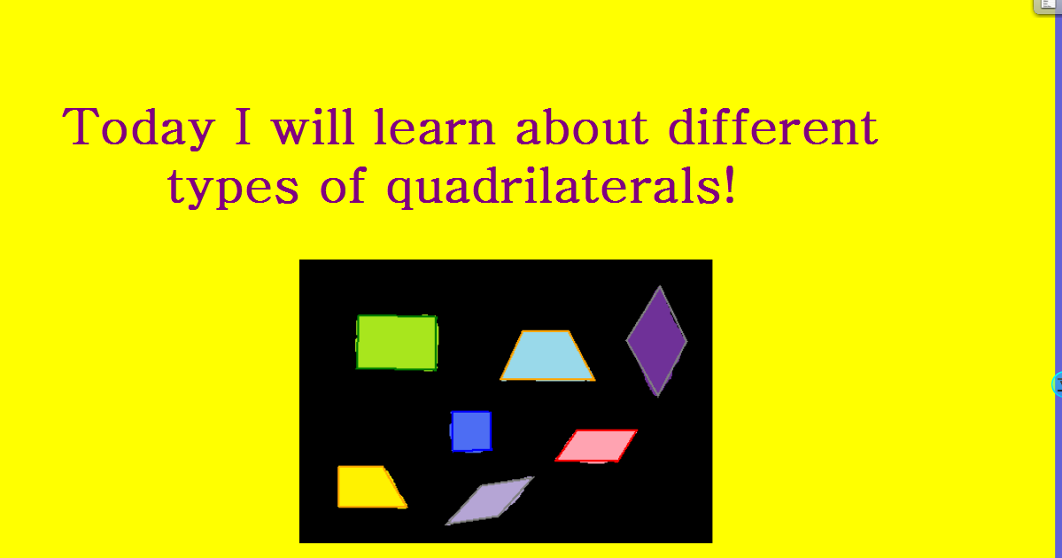

Lesson Plan 2:2
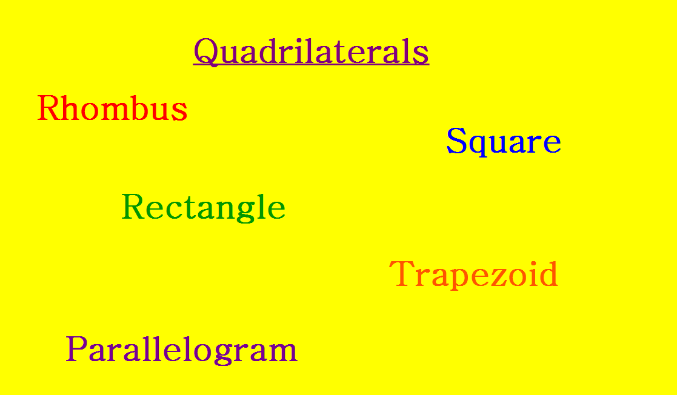

Lesson Plan 2:3
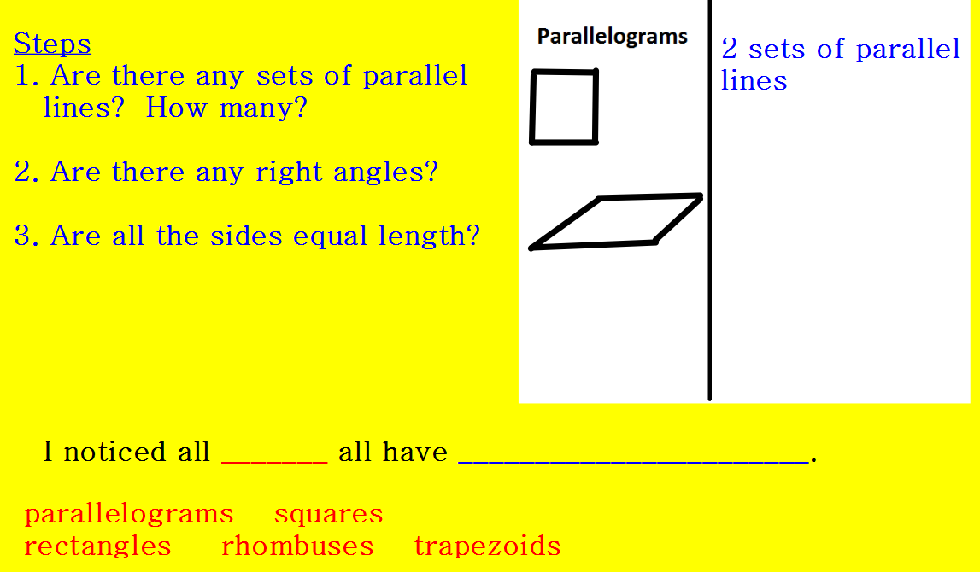
Lesson Plan 2:4
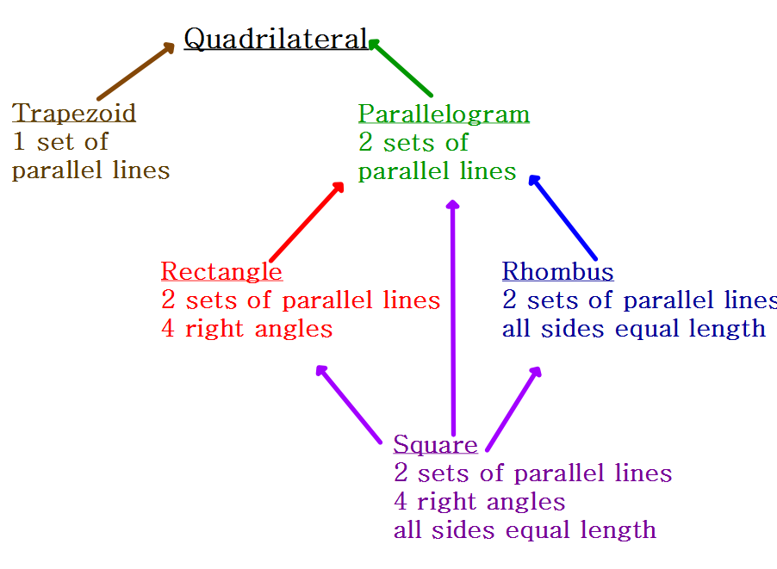
Lesson Plan 2:5
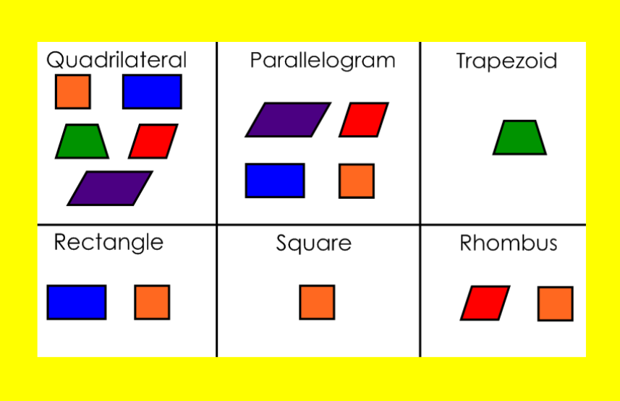

Instructional Materials: Center signs + quadrilateral cut outs
Lesson Plan 2:6
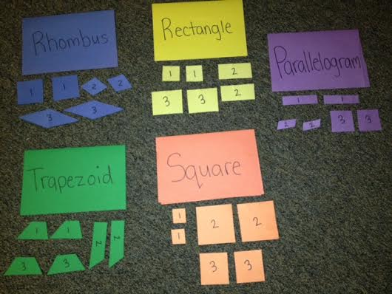
Instructional Materials: Handout (size adjusted to fit in document)
Lesson Plan 2:7
NAME:________________________________________

Quadrilateral Exploration 2

Name of Quadrilateral | What do they ALL have in common?
Trapezoid

Parallelogram

Rectangle

Rhombus

Square

Quadrilateral relationship chart handout
Lesson Plan 2:8
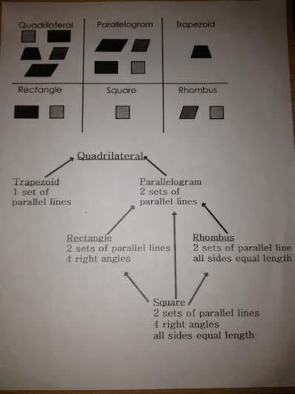

Celeste Padilla
Third Grade
Subject: Math-Geometry
Date: 2/28/14
Lesson Plan 3: Quadrilateral Riddles
Whole class

Standards: CCSS.MATH.CONTENT.3.G.A.1
Understand that shapes in different categories (e.g., rhombuses, rectangles, and others) may share attributes (e.g., having four sides), and that the shared attributes can define a larger category (e.g., quadrilaterals). Recognize rhombuses, rectangles, and squares as examples of quadrilaterals, and draw examples of quadrilaterals that do not belong to any of these subcategories.

Content Objective: Students can identify and define attributes for quadrilaterals.

Language Objective: Students can contrast the attributes of two different quadrilaterals.

Quadrilateral Riddle
If I were a _____ I would have ________________ and __________________ . I would NOT have ____________ because that would be a ___________.

(color coded for 2 different quadrilateral, quad 1, quad 2)

If I were a _____ I would have ________________ and __________________ . I would NOT have ____________ because that would be a ___________.

Vocabulary
- Quadrilateral
- Rhombus
- Square
- Rectangle
- Parallelogram
- Trapezoid
- Parallel lines
- Right angle
- Side
- Length (different or equal)

Assessment:
Formative: Students will TPS during Envision guided practice(1-7), I will listen in on conversations. I will then use calling cards to assess individual and class understanding. Next students will complete independent practice (8-11), I will circulate around the room checking student work and making note of my observations.

Summative: Students will write two quadrilateral riddles, I will collect and read these to assess individual and class understanding.

Materials needed:
- Topic 5 flipchart
- Envision textbook + slides
- Pencils
- Quadrilateral handout
- Quadrilateral riddle handout

Differentiation:
AM and ReM will be sat in the front to limit distractions.

Students will be strategically paired such as IL/NB, AB/AM, ReM/LG, YC/JP, and SG/DA.

IL and NB will be paired up because I supports N’s needs and give I sense of responsibility

KR needs plenty space to write on his paper and a weighted pencil.

Activity itself lends itself to differentiation because there are multiple entry and exit points.

Instructional Sequence:
Introduction
- Tap prior knowledge: Students will be seated at their desks with their math journals, math text books open, and their relationship sheet out. I will explain that today we will be using what we learned yesterday about the attributes of the different types of quadrilaterals to identify and to write our own riddles! I will use calling cards to generate a list of the different quadrilaterals.
- Review Relationship Chart: After we generate our list I will have students look at their sheet and turn to a partner to share anything they notice or any similarities or differences between the different types of quadrilaterals. I will circulate and listen in on conversations. I will then use calling cards for students to share out what they noticed (4). I will then explain how they can use this sheet as a tool to see the different attributes of the quadrilaterals and how they are similar and different. (For example under parallelogram there are arrows leading to square, rhombus, and rectangle because they all have 2 sets of parallel lines.) I will walk through these relationships after tapping the ideas the students have.
Body
- Envision Practice: We will do guided practice 1-7 together. We will read the problem as a class. The first problem or two I will do a think aloud on how to solve it using my relationship chart as a tool to help me. The next several problems, we will read the problem together but students will solve independently or with a partner. As they are working on the problem, I will circulate around the room, making notes on individual and class understanding. After a minute or so we will solve the problem together or I will use calling cards for a student to give their answer and explain their thinking. Next students will have 10 minutes to complete 8-11 independently or with a partner. I will circulate and make note of understandings.
- Introduce + model riddle: Next, students will put their books and math journals away and meet me quickly and quietly at the Promethean board. I will explain that we will now be using all of our knowledge from our explorations and practice to write quadrilateral riddles!! I will display a blank template of the riddle and explain that we will be writing about one quadrilateral in the first part and its attributes (highlight) and then contrasting it with another quadrilateral (highlight dif color). I will do a think aloud as I write an example. “If I were a, hmm let me look at our list of quadrilaterals, oh a square, if I were a square I would have, ohh let’s look at our tool that has the attributes! If I were a square I would have 4 equal sides and 4 right angles. Oh no I have to choose something that it is not, hmmm I would NOT have only one set of parallel lines because that would be a trapezoid. Wow, that was fun writing a riddle for math!! So each of you are going to be writing 2 riddles!!! Remember to use your tool sheet and read the sentences carefully so you are matching the attributes with the right quadrilaterals, does anyone have any questions?” (depending on how students are feeling, I can model another one or explain the assignment again). “Can someone repeat how many riddles we are writing? (cards) Can someone repeat my direction? (cards) Okay, great, have fun creating riddles my mathematical writers!!! You have 10 minutes on the timer, ready, set write!” Pass out sheets and dismiss students back to their desks
Closure
- Write riddles: I will circulate and monitor students work, I will not be asking any questions or providing too much assistance. When they are done I will collect and read their riddles. We will debrief quickly about their experience writing for math and I will explain the importance of being able to explain your thinking and write during math time.

Instructional Materials: Flipchart
Lesson Plan 3:1
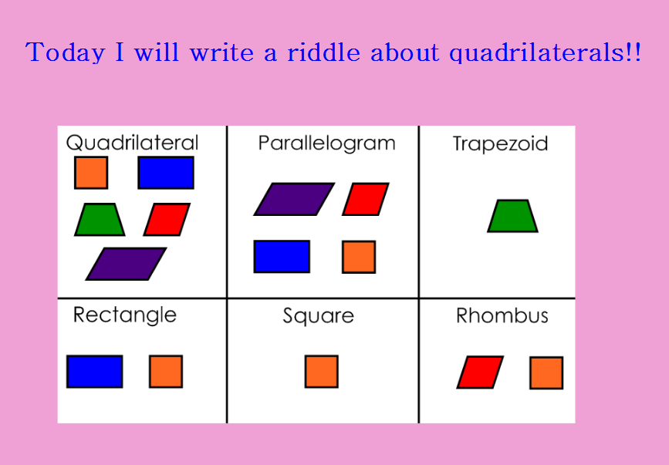
Lesson Plan 3:2
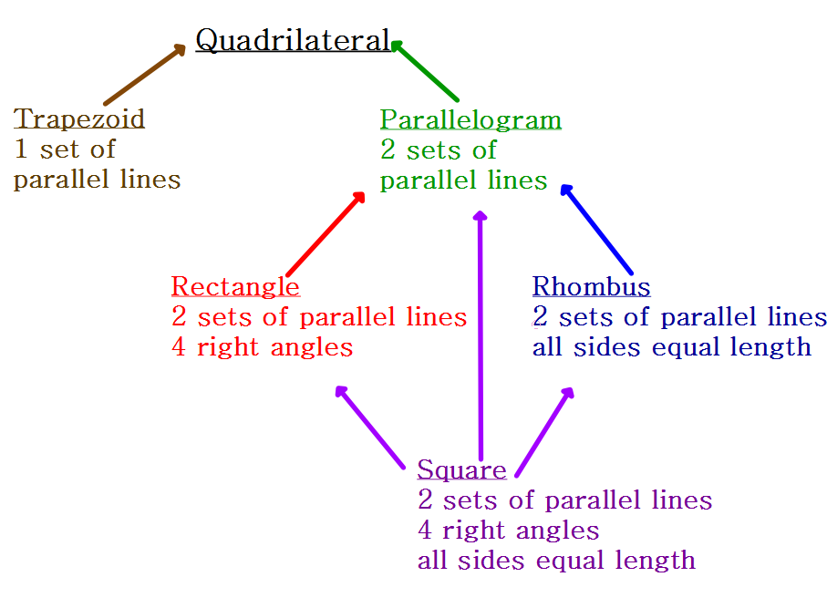

Lesson Plan 3:3
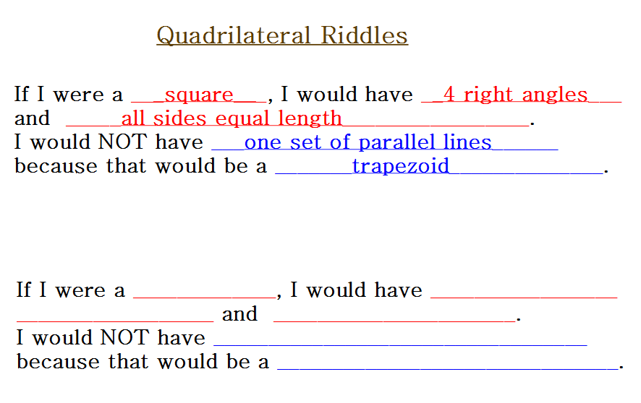

Instructional Materials: Envision Slides and Textbook

Lesson Plan 3:4
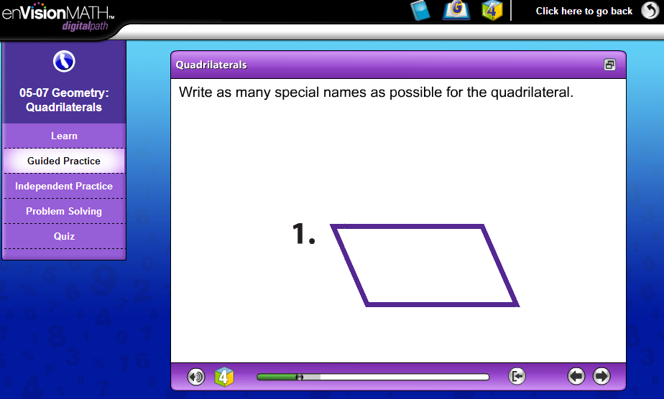

Lesson Plan 3:5
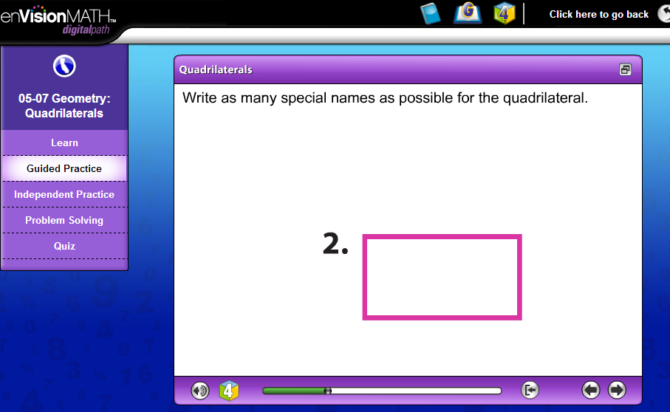

* Individual slide for each guided practice slide (1-7)

Lesson Plan 3:6
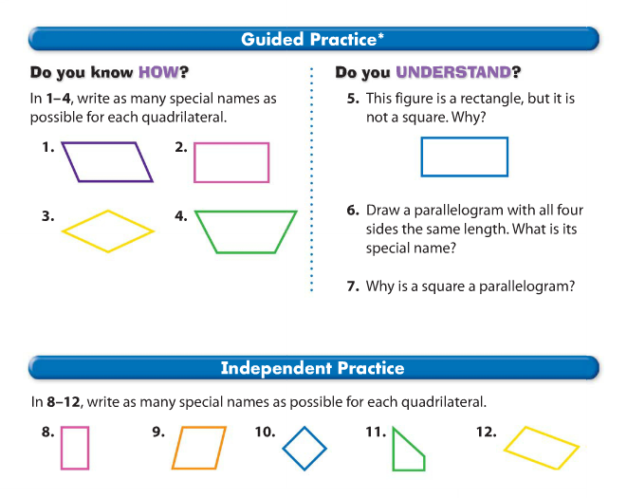
*Snap shot of student textbook.
Instructional Materials: Riddle handout (format smaller to fit in document)
Lesson Plan 3:7

NAME:________________________________________________

QUADRILATERAL RIDDLES

Riddle #1
If I were a ___________________________________ I would have

____________________________________________________

and ________________________________________________ .

I would NOT have________________________________ because that

would be a ______________________________.

Riddle #2
If I were a ___________________________________ I would have

____________________________________________________

and ________________________________________________ .

I would NOT have________________________________ because that

would be a ______________________________.

Re-teaching Materials
Lesson Plan 3:8
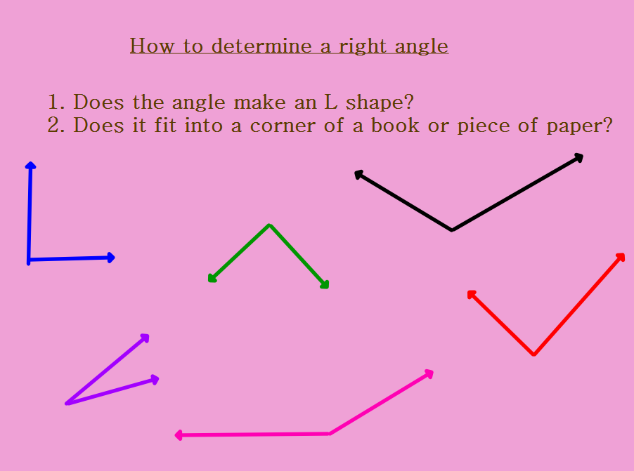

Lesson Plan 3:9
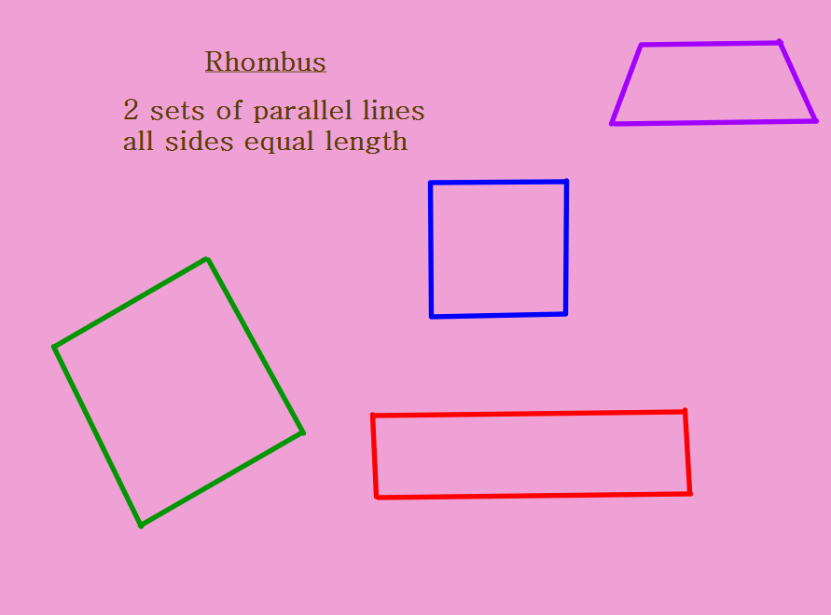

Lesson Plan 3:10
