Lesson Plan
How Many Bears Can Live in This Forest?
Name: Celeste Padilla
Grade Level: Third Grade
Content Area: Science
Date for Implementation: 12/9-12/13 (sometime in this period)
Lesson Title: How Many Bears Can Live in this Forest?

Standards:
NGSS 3 LS4-3 (Next generation Science Standards Third Grade Life Science 4-3)
Construct an argument with evidence that in a particular habitat some organisms can survive well, some survive less well, and some cannot survive at all.

Content Objective: Students will define orally and in writing the major components of habitat (food, water, shelter, space) and limiting factors (ex: inadequate food/shelter, disability such as being injured or blind). Students will explain in writing how limiting factors affect an animal’s survival.

Language Objective: Given sentence frames and content specific vocabulary and conjunctions students will be able to identify a major component of habitat and explain how this component can be a limiting factor in bear survival in a habitat.

Assessment:
Formative Assessment Task
I will circulate around the room while we are filling out our data chart (different food types, how much of each a bear needs, what happened to blind, injured, and mama/baby bear). While students are discussing the results/thinking about their summary statements, I will ask:
- Were you able to survive, why or why not?
- Was blind/injured/mama bear able to survive? Why or why not?
- How can this information help you write your statement? Think about what happened during our simulation

Summative Assessment Task
I will look at completed data charts and listen to/read students’ summary statements.

Materials Needed:
- Few sheets of five different colors of construction paper which will be cut into square and labeled with a number representing pounds
  - red-meat
    - 8lb (3)
    - 4lb (16)
  - yellow-insects
    - 12lb (3)
    - 6lb (16)
  - blue-berries
    - 20lb (3)
    - 10lb (16)
  - green-plants
    - 20lb (3)
    - 10lb (16)
  - orange-nuts
    - 20lb (3)
    - 10lb (16)
- Black marker
- Envelopes (22 1 per student)
- One blindfold
- A poster board or Promethean board for data chart
- Rocks or heavy object to place on den(envelope) so it will not fly away

Differentiation:
Language Modifications

During the Bear visualization read aloud, the following terms will be defined within the read aloud but I will be sure to emphasize the survival, habitat, and limiting factors in the next part of the activity because those words are essential to understanding the content objective

Content Specific Vocabulary | Definition
Habitat | The place where an animal lives and the resources it provides
Limiting factors | Something which affects the survival of an animal or population of animals
Mammal | An animal that breathes air, warm blooded, and produce milk to fee their babies
Omnivore | An animal that has a mixed diet of meat, vegetables, nuts, and fruit
Scarce | Only a small or limited amount available
Den | A bears home or shelter
Predator | An animal that lives by preying and eating other animals

For all students, but especially my ELs, I will preteach the necessary vocabulary. I will follow the format Mr.C has used and present a vocabulary slide show with definitions and illustrations. Each word will be presented and explained, then students TPS the definition in their own words, and lastly students record this definition and examples on their worksheets drawing from their experience during the black bear simulation.

Academic Vocabulary
Survival
Habitat
Limiting Factor

For students K, D, DG, R, J, A, and Ag, I will have a graphic organizer available with class notes on the discussion of what are components of habitat, limiting factors, and how they affect bear survival

Components of Habitat | Limiting factors | Effects

I will provide (refer to language objective) various sentence stems for the variety of English proficiency in my classroom.

1) A major component of habitat is __________________. A limiting factor is _____________________. The/A __________________ can limit bear survival because _________________________.

2) A major component of habitat is ___________________ and an example of a limiting factor is ______________________________. The/A______________________ can be a limiting factor in bear survival because it _____________________________ and __________________________.

3) The major components of habitat are _____________, _________________, _______________, and _______________. An example of a limiting factor is _____________________ and it influences bear survival because ________________________________ and ______________________________.

Behavior Modifications
For student I. and K., these students work well together in helping each other with their needs, I will ensure that they seat next to each other during the computations.

N. is responsible and will make a great assistant for the blind bear, blind bear will be As.

Jo. will be injured bear because he is well behaved and will not act up.

Student I. responds well to responsibility, I will assign her as Mama bear and baby bear will be imaginary

For student J. and N. or any other students that may finish early, I will ask them to determine how much more food did they need in order to have a balanced diet. What about blind bear, injured bear, and mama + baby bear? I will also encourage them to use the last sentence stem when they write their statements

Instructional Sequence:
Introduction
- Tap Into Student Prior Knowledge (5 min)
  - Call students to the rug near the Promethean Board
  - ‘Hello scientists, I know you have been doing a lot of research about animals in a wide range of habitats, such as whales in the ocean or penguins in the arctic. Now, please raise your hand quietly and I will call on you. Can anyone explain what a habitat is or given an example of one? Can anyone given an example of something we find in a habitat?’
  - If students are having difficulty coming up with examples or description I can do I think aloud about my own response to the question to get kids thinking again and to model an explanation. I will also mention the previous read aloud to jog their memory.
- Hook’em! (5-7 min)
  - ‘I know you are all experts in why animals live in groups (previous science exploration), but today we are going to learn about why some animals do not live in groups as a result of their needs and their habitat. So today, we are going to pretend to be black bears and the Lincoln Acres playground is going to be our habitat! This is very important, in order for us to transform I need you to calmly close your eyes, keep your hands to yourself, and visualize what it would be like to be black bear. I will begin reading my story once I see all my bears silent and ready to listen and eyes closed. As I read listen for any of our vocabulary words and really visualize what it would be like to be a black bear ’ Wait until all students are ready and read Black Bear Visualization (during this time Mr. C will pass out envelopes to each student’s desk)
Body (20-25min)
- ‘Alright everyone open your eyes, you now have an idea of what it is like to be a black bear in a forest. Today we are going to be doing a very cool activity but it is extremely important that you follow directions so we can do it. In just a few minutes we are going to step out into the forest of Lincoln Acres as bears, each bear will have a den. Your den is actually going to be an envelope with your name written on it (Show them an example, Miss Celeste’s Den). You may quietly and calmly return to your seats to write your name on your den. When you are done writing your name put your pencil down and look at me please so I know you are ready.’
- Wait to see majority of class is finished to continue to the next step. ‘You are now all black bears (allow a few moments for excitement) and we are almost ready to go out into the forest and gather food but not all black bears are the same. One young black bear was recently injured when it slipped on a rock, hurting its foot. _____ you will be the injured bear, as you gather food you may gather by hopping on one leg. Another bear was very curious and got too close to a porcupine and was blinded by the quills! _______ you will be blind bear and ______you are blind bear’s brother/sister. Blind bear you will be blindfolded as you gather your food and _____ you will help guide blind bear to the food. Lastly, there is another bear in the forest, a mama bear with a cub, or a baby bear. _______ you will be mama bear and you will have to try and get twice as much food to feed yourself and your baby. Lastly, for all of my bears, when we go out to gather our food it is very important that we act like bears. Bears do not run for their food, they walk, you may walk fast but you may not run. Alright, I’m looking for tables of bears that are ready, pencils down, sitting up straight, quiet (call on tables to line-up)Table ___ grab your den (hold up my envelope) and line up please, Table ____ . . . (repeat until all students are lined up and have their enveloped/den with them.) We will know walk quietly down to our forests, remember there are other classes we will pass by and we must be quiet and respectful so we do not disturb them.’
- Walk students quietly down to the lower black top recess area. Have students line up on the perimeter of the area. ‘Everyone please place your den done and cover it with your rock so it will not fly away. I will be placing out food for my hungry bears to gather, you are only allowed to grab one piece of food at a time. (Demonstrate walking fast, picking up one piece of food, and placing it in my envelope)You can walk fast to grab one piece of food and then return to your den to place your piece of food inside your envelope, after you have done this you can go grab another piece of food. Remember, _____ blind bear you will wear blind fold and _____ you will guide him/her to the food and back to your dens. Injured bear, you will only be able to hop on one foot to get your food. Mama bear, you can walk like the rest of the bears. Can someone tell me how many pieces of food you can grab at a time? ….. Can someone tell me how my bears will gather their food, walking or running?....., Alright well my bears are hungry so let’s begin. Black bears please close your eyes ( I will scatter the food) ok you can open your eyes and begin to gather your food!’
- Redirect, reinforce, and remind students when necessary during the activity
- Alright, it seems we have run out of food! Please pick up you den and your rock and line up (this will be near where the students line up after recess or lunch). Remember my bears we need to be quiet for the humans who are in their classrooms right now’ Return to class.
- Have students settle in, drink water, chat for a bit, then get their attention after a minute or two. While they are doing this I will pass out their worksheets.
- I will state and show (cue card) that the noise level is at a 1. Ok my black bears it is time to see how much food you have collected. You may empty your envelopes. What do you notice on the pieces of paper? (call a student or two) What do you think these numbers represent? (call a student or two) Yes this is how many pounds of food you collected for that color. On the Promethean display the sheet they have and explain what the colors represent and where to record their results. State that this is independent work time. Allow a couple minutes for computation. Next explain how much food a black bear needs to survive. I will have students determine whether or not they survived by comparing how many pounds of food they collected to how many they needed. I will ask students to raise their hands if they survived. We will record this on our sheet as a fraction! Lastly, I will ask mama, blind, and injured bear if they survived. Student will record this on their sheet and will display where to record this on the promethean board.
- Next, I have a mini vocabulary lesson/discussion about survival, habitat + its components, limiting factors, and the effects on bear survival. I will state and show (visual cue card) that the noise level is at 1. I will present the definition of the word on the promethean board with an illustration. Students will echo repeat each vocabulary word with me. Students will TPS (think-pair-share) with their partner the definition in their own words and then record it on their sheet. Between each word I will use the calling cards to call on 2 students.
Closure (5-7min)
- I will recap on what are habitat components, how they can be limiting factors, and the effects on bear survival. This information will be recorded on a graphic organizer. I will allow the students to TPS with a partner then I will use calling cards to call on students to help me fill out the chart. I will model how to use the sentence stems with the vocabulary we reviewed and the ideas discussed during the creation of the graphic organizer.
- Lastly, students will work independently to fill out their summary statements. I will restate and show that the noise level is at zero. If students finish early they can try to use the last sentence stem as a challenge and/or figure out how much more food they needed to have the perfect black bear diet and/or survive.
- Complete worksheets.
- Summarize our learning about bears, limiting factors, and survival through the use of the sentence stems and our graphic organizer. I will recap how this relates back to why animals live in groups in that sometimes in order to overcome a limiting factor such as an injury or finding enough food a group can be beneficial and sometimes it is not beneficial. I will encourage my students to read non-fiction books during independent reading to see if they can make any connections between what we learned about today and the text!

Instructional Materials
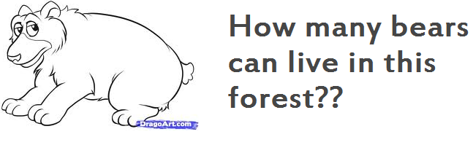NAME:__Ms.Celeste____
How much food I collected!! How much food a bear needs!!
Color | Amount | Color | Amount
Orange  (Nuts) |  | Orange  (Nuts) | 20
Blue  (Berries) |  | Blue  (Berries) | 20
Yellow  (Insects) |  | Yellow  (Insects) | 12
Green  (Plants) |  | Green  (Plants) | 20
Red  (Meat) |  | Red  (Meat) | 8
Total |  | Total | 80

YES or NO
Did mama bear and baby bear survive?________________
Did blind bear survive?___________________
Did injured bear survive?__________________

Survival | The ability to stay alive  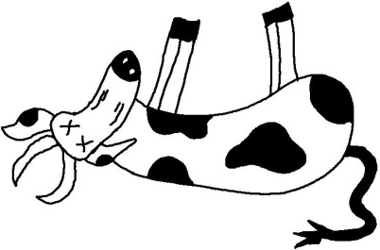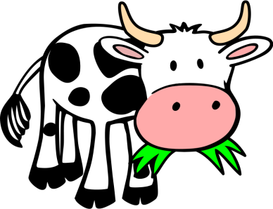
Habitat | The place where an animal lives and the things you find in this place  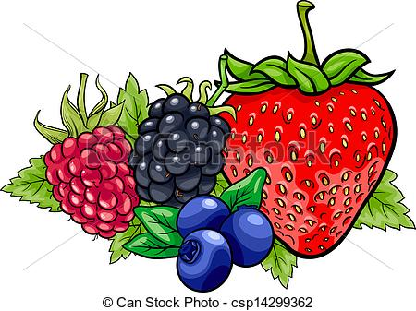  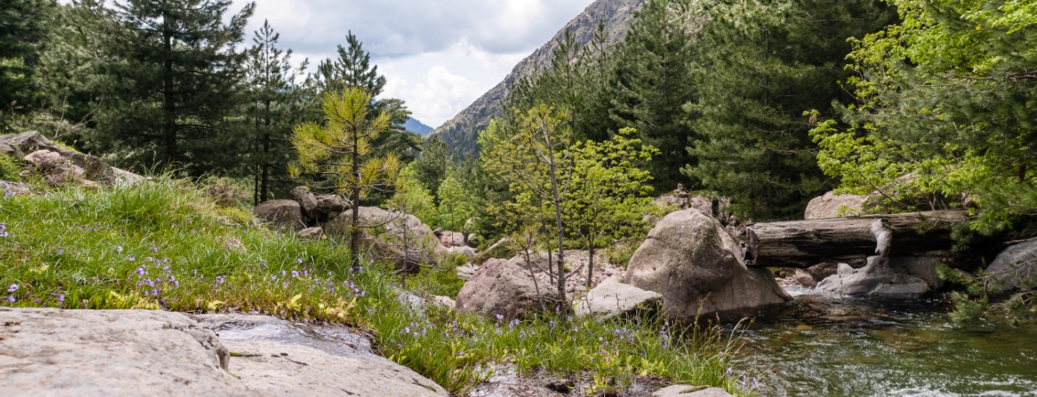
Limiting Factor | Something that controls whether an animal will stay alive or not  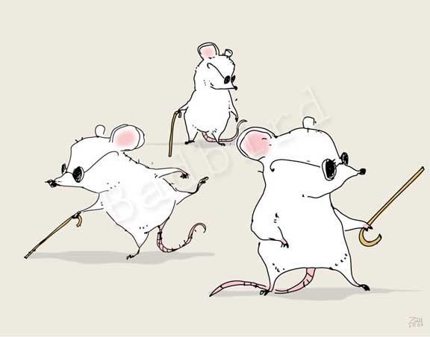

A major component of habitat is ____________________. A limiting factor is _______________________. The/A __________________ can limit bear survival because _______________ ________________________________.

A major component of habitat is ___________________ and an example of a limiting factor is________________. The/A______________________ can be a limiting factor in bear survival because it _____________________ and_________________.

The major components of habitat are ________________, ______________ , _________________, and __________. An example of a limiting factor is _____________________ and it influences bear survival because__________________________ and_____________________________.

Components of a Habitat | Limiting Factors | Effects

*This sheet was used on Promethean board during class discussion and vocabulary instruction
Student Worksheet
NAME:___________________

How much food I collected!! How much food a bear needs!!
Color | Amount | Color | Amount
Orange  (Nuts) |  | Orange  (Nuts)
Blue  (Berries) |  | Blue  (Berries)
Yellow  (Insects) |  | Yellow  (Insects)
Green  (Plants) |  | Green  (Plants)
Red  (Meat) |  | Red  (Meat)
Total |  | Total

YES or NO
Did mama bear and baby bear survive?________________
Did blind bear survive?___________________
Did injured bear survive?__________________
Vocabulary
Survival
Habitat
Limiting Factor

1) A major component of habitat is ____________________. A limiting factor is _______________________. The/A __________________ can limit bear survival because ___________________________________________________________.

2) A major component of habitat is ___________________ and an example of a limiting factor is ______________________________. The/A______________________ can be a limiting factor in bear survival because it _____________________________ and __________________________.

3) The major components of habitat are ________________, _________________, _________________, and __________________. An example of a limiting factor is _____________________ and it influences bear survival because_____________ _________________________________________and___________________________________________.

*student worksheet was resized to fit in this document, actual worksheet had narrower margins and was in a bigger font to allow more space to write

Planning Commentary: Science CAT

- What is the central focus of the learning segment? Apart from being present in the school curriculum, student academic content standards, or ELD standards, why is the content of the learning segment important for your particular students to learn? (TPE 1)

The central focus of my lesson is for my students to learn why some animals do not survive well and others do not survival at all as a result of limiting factors. I want for my students to discover this information through inquiry science. Thus by utilizing a bear habitat simulation, students will learn through experience by collecting food and examining survival of oneself and peers. The content of this lesson is important because it builds a foundation for critical thinking that will be utilized in other content areas. This idea of limiting factors influencing one’s survival can be integrated in the other content areas. For example, this scientific understanding will aid students in comprehending topics in social studies such as wars, colonialism, and population trends in relation to limiting factors and survival.

- Briefly describe the theoretical framework and/or research that inform your instructional design for developing your students’ knowledge and abilities in both literacy and academic language during the learning segment.

In the construction of my lesson plan I referred frequently to Becoming Scientists by Rusty Bresser and Sharon Fargason. Bresser and Fargason discuss the importance of having science instruction be student oriented in that a teacher does not lecture about information but rather allows students to discover scientific concepts. In addition, both authors discuss the importance of allowing students to experience concepts and develop a concrete understanding before abstract terminology is introduced. It is more important for students to truly understand a concept versus being able to remember a scientific term. I utilized this information in the construction of my lesson by providing students with the opportunity to discover and develop their own knowledge before introducing the scientific/academic language explicitly. I also utilized Foundations for Teaching English Language Learners: Research, Theory, Policy and Practice by Wayne Wright as a guide in constructing my scaffolds for the various English proficiency levels of my students. I will utilize strategies such as wait time, think-pair-share, vocabulary chart, hands on activities, graphic organizers, and visuals to aid student understanding during the lesson. These strategies provide excellent scaffolds for my English language learners but are beneficial for all of my students.

- Given the descriptors of students that you provided in the Context for Learning, how do your choices of instructional strategies, materials, technology, and the learning task reflect student’s backgrounds, developmental levels, interests, and needs? Be specific about how your knowledge of these students informed the lesson plan, such as the choice of text or materials used in the lesson, how groups were formed or structured, using student learning or experiences (in or out of school) as a resource, or structuring new or deeper learning to take advantage of specific student strengths. (TPEs 4, 6,7,8, 9)

Upon selecting a topic for this lesson I wanted to tap into student background knowledge. Recently, my students have been learning about why animals live in groups, thus most of my students understand terms such as habitat, resources, mammal, and survival. I wanted to build off of this knowledge and take it in a different direction such as why some animals are not able to live in groups and thus some animals survive well, other less well, and some do not survive at all. In addition, in my classroom there is a variety of developmental levels thus I wanted to create an activity with various scaffolds to support the participation of all of my students. The simulation itself was wonderful because all students were able to participate and were able to build a foundation for understanding the scientific concepts because they experienced them in a realistic setting. This helped make content accessible to all. I was able to meet the various needs of my students through an assortment of strategies I utilized to provide support for my English language learners, my students with IEPS, and my students with behavioral needs. I carefully structured partnerships in which each one contained a student of a higher and lower proficiency level to help one another (this is the way the classroom seating is organized). I have also paired I with N because I responds well to responsibility and N works well in receiving aid for I. My other students with IEPS have similar partnerships (N-I, Ai-As, An-J, D-S, and K-J). Most of my students enjoy reading texts about animals thus I will engage my students during this lesson by utilizing their interests. Most of my students take pleasure in being outdoors thus many will appreciate that this lesson is taking place outside on the black top.

- Consider the language demands of the oral and written tasks in which you plan to have students engage as well as the various levels of English language proficiency related to classroom tasks as described in the Context Commentary. (TPE 7)

  - Identify words and phrases (if appropriate) that you will emphasize in this learning segment. Why are these important for students to understand and use in completing classroom tasks in the learning segment? Which students?

After looking over my content objective and the demands of the lesson I decided that I would focus on building student understanding of the words habitat, limiting factors, scarce, and survival. These words are important in understanding the idea why some animals survive well, some survive less well, and others do not survive at all. I have structured in multiple opportunities for the students to practice using the words including echo repeat, teacher defining terms, partner share, writing a definition in original words, class share out, and practice orally/writing sentence stems with the academic language. Most of my students are familiar with the word habitat and some may have an understanding of the other words. Overall though this academic vocabulary to for all of my students but I have integrated multiple SDAIE strategies for my ELs in the class in order to make the content accessible. Lastly, I have utilized various proficiency level sentence stems to help my students practice using the academic vocabulary, understand the meaning, and understand the connection between these scientific ideas.

  - What oral and/or written academic language (organizational, stylistic, and/or grammatical features) will you teach and/or reinforce?

I will be teaching students how to create statements of their learning through the use of my sentence frames. I will be reinforcing this idea of providing an example of a term and explaining the relationship between two ideas using because. For example, in reference to my first sentence stems, student will be practicing how to give an example of a term to show your knowledge of its definition (examples of components of habitat and limiting factors). Students will also practice forming a sentence to substantiate their claim using evidence and the conjunction because. Sentence stem two has these same core ideas but steps it up a notch to include a conjunction, and, to create a compound sentence. Sentence stem three also has the same academic concepts as the previous but students are now utilizing commas to create a list of ideas along with substantiating their claim. The language genre of this is lesson is a scientific explanation. Thus the linguistic features (or language function) are the use of casual connectives (because), academic vocabulary (as listed in lesson plan), and evidence (from own observation and/or class discussion).

  - Explain how specific features of the learning and assessment tasks in your plan, including your own use of language, support students in learning to understand and use these words, phrases (if appropriate), and academic language. How does this build on what your students are currently able to do and increase their abilities to follow and/or use different types of text and oral formats?

Theoretical foundations for the lesson
I am implementing various strategies to support the learning of all of my students, especially my ELs (you can refer to highlighted portion of the lesson and language modifications). I reviewed the discussion we had in lecture of EDS 351 on 11/26/13 with our discussion of strategies to include but not limited to echo repeat, visual aids, gestures, graphic organizers, TPS, and sentence stems. In addition, in the construction of my language modifications I referred to the work of Dutro + Helman (2009) in that academic language must be taught explicitly and students must have multiple opportunities to practice it. Also, I will ensure my students understand that language is both a tool and has a function. The toolkit includes vocabulary or concepts. The function is what you do with that tool, such as using the tool to explain one’s self or thinking. This is demonstrated in my instruction of vocabulary and how that vocabulary can be used to explain one’s learning through the sentence stems. Lastly, I utilized an important concept presented by Walqui (2009) in that “Learning is always based on prior knowledge and experience. English language learners must have equal access to knowledge that is valued in school.” (Pg. 1) I will tap into student prior knowledge, such as that of animals, habitats, and survival and will transfer this knowledge to the content of this lesson. I will also build student vocabulary and understanding through explicit instruction and practice.

Integration of theory into the lesson
I will be using echo repeat during my explanation of the vocabulary terms to ensure students are pronouncing the words correctly so they will recognize the word when they hear it again. I will be utilizing visuals to aid in my explanation of rules, definitions, or directions. For example, I will both state and demonstrate the expectations for how my bears will collect their food. In addition, I will utilize graphic organizers to record the ideas of students when I am tapping into their knowledge during a class discussion. I will also have graphic organizers available on student worksheets to help better organize their thoughts and work. During the bear visualization read aloud, many of the academic scientific vocabulary will be defined orally in the passage but the vital words will be reviewed during the mini vocabulary lesson through the use of visuals, TPS, and writing. Also, I will utilize Think-Pair-Share to allow students a moment to collect their thoughts in English and have a chance to share their idea with a partner before we have a whole class share out. In my lesson I have structured in great support for the students to experience the vocabulary words, hear explanation of the terms, and practice using the terms with a partner. The last aspect of the lesson will be completion of the sentence stems in writing. I have three different levels, I am requiring all of my students to complete the first stem but I will encourage students to challenge themselves to use stems 2 or 3 to push them in the development of their English language. Student are familiar with the features in stem 2 such as providing an example of a term and substantiating a claim with evidence, thus students will gain practice in this skills and expand their knowledge of complex sentence formation with stems 2 and 3. Sentence stems will be practiced both orally and in writing. Lastly, the vocabulary and ideas about animal survival in the lesson builds off of the class’ knowledge about animals such as why animals live in groups, how animals stay alive, and animal environments.

- Describe any teaching strategies you have planned for your students who have identified educational needs (e.g., English learners, GATE students, students with IEPs). Explain how these features of your learning and assessment tasks will provide students access to the curriculum and allow them to demonstrate their learning. (TPEs 9. 12)

I will be using strategies such as choral response, echo repeat, graphic organizers, think-pair-share, sentence stems, and visuals to make the content accessible to all of my students. Some of my students such as Ai, I, An, and D are easily distracted and need some type of organizer that they can refer back to. I have 7 ELLs of various proficiency levels thus I will use TPS for students to practice using English with a partner to construct their ideas. I will also use explicit vocabulary instruction with visuals and echo repeat. I will use choral response in repeating the definition of a word or stating whether a specific bear was able to survive. In addition, I will provide several sentence stems to push my ELLs to use more complex sentence structure but to also challenge students such as J or N who are advanced. Lastly, students will have multiple opportunities to demonstrate their learning because some excel orally and others in writing. I will have students TPS before whole class discussion. This gives me two opportunities to assess the students, one with their partners and the other whole class. TPS is a wonderful opportunity to practice speaking English in a smaller setting before sharing with the whole group, thus students will have two chances to demonstrate their knowledge orally. I will also have a writing component to my assessment in which students will complete summary statements about their learning and they have the choice of different leveled sentence stems. Students will self differentiate and those who are shy to share or perform better writing versus orally will have the chance to display their knowledge.

Language demands can be related to vocabulary, features of text types such as narrative or expository text, or other language demands such as understanding oral presentations. For early readers/writers, this will include sound-symbol correspondence and a word as a text but might also involve the development of oral skills which are antecedents to reading and writing, oral narratives and explanations.

